SmartCare v0.3 - Domain Model Workbook
Week 6 student resource

Requirement-to-Concept Trace
Requirement | Concept | State/behaviour | Decision
Patient record creation | Patient | Patient stores identity, date of birth, identifier and contact details; supports creation and validation. | Include
Patient search and viewing | Patient | Patient records can be searched and displayed using name or identifier. | Include
Practitioner management | Practitioner | Practitioner stores name, role and availability; supports creation, updating and deactivation. | Include
Appointment booking | Appointment | Appointment links one Patient to one Practitioner and stores date, time, duration and status. | Include
Duplicate appointment prevention | Appointment, Practitioner | Appointment checks for overlapping bookings for the same Practitioner. | Include
Appointment status updates | Appointment | Appointment validates and changes status, such as Booked, CheckedIn, Completed, Cancelled or NoShow. | Include
Patient appointment history | Patient, Appointment | Patient provides access to linked past and upcoming appointments. | Include
Practitioner schedule and history | Practitioner, Appointment | Practitioner provides access to daily and historical appointments. | Include
Appointment search and filtering | Appointment | Appointment records can be filtered by patient, practitioner, date range and status. | Include
Authentication and role permissions | UserAccount (provisional) | Users log in and receive permissions according to their role. | Provisional

CRC Cards

Patient
Responsibilities | Collaborators
Provide the patient’s appointment history | Appointment
Validate Required Patient information | ---

Practitioner
Responsibilities | Collaborators
Store and update availability information | ---
Identify whether a requested time is available | Appointment

Appointment
Responsibilities | Collaborators
Store appointment date, time and duration | Patient and Practitioner
Associate exactly one practitioner with an appointment | Practitioner

Optional class
Responsibilities | Collaborators
Store the affected record identifier | Patient, Practitioner, Appointment
Store the action performed | Patient, Practitioner, Appointment

UML Class Diagram
Insert/draw UML here. Include 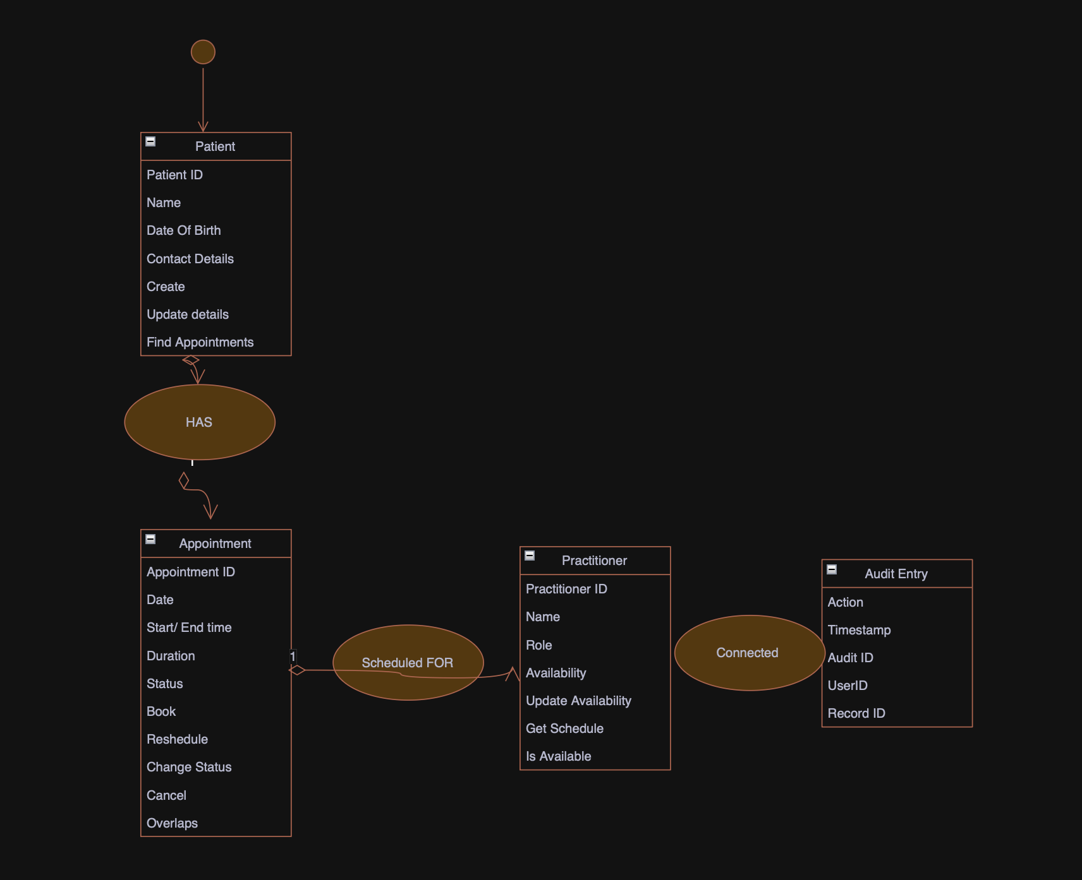defensible relationships and multiplicities.

Design Rationale
Explain class selection, responsibility allocation and key relationships.
- The main classes are Patient, Practitioner and Appointment because they directly represent the main business concepts in the SmartCare problem. They correspond to the records that staff currently manage in spreadsheets and paper files.
- Patient is responsible for patient-specific information and access to appointment history. It should not manage practitioner schedules or appointment conflict rules. Practitioner stores professional and availability information and provides schedule-related information. It should not store duplicated patient details.
- Appointment is the central relationship object. It connects exactly one patient with exactly one practitioner and records the time and status of the appointment. It is the appropriate place for appointment-specific behavior, such as cancellation and status transitions. Duplicate prevention requires checking the practitioner’s other appointments for overlapping time ranges.
- The relationship between Patient and Appointment is one-to-many because a patient may have many past and future appointments, while each appointment is for one patient. The relationship between Practitioner and Appointment is also one-to-many because a practitioner may have many appointments, while each appointment is assigned to one practitioner.
- Clinic is not included in the core diagram because the current requirements describe one SmartCare clinic and do not require multi-clinic behavior. It should be added later only if clinic locations, clinic-level ownership or multi-site reporting become confirmed requirements.

AI Design Review Record
AI suggestion | Evidence | Decision | Reason | Model change
Patient Manager | Patient creation, search and update are required, but no independent “manager” business concept is specified. | Reject as domain class; retain provisionally as an application service | Patient data and patient-specific behaviour belong in Patient. A manager class could become a large procedural class. | Add patient operations to Patient; use a service layer only if application coordination is needed.
Practitioner Manager | Practitioner administration and availability are required, but “manager” is not a business entity. | Reject as domain class; retain provisionally as an application service | Practitioner data belongs in Practitioner; scheduling logic should not be hidden in a broad manager class. | Add availability responsibilities to Practitioner; use a service only for coordination.
Appointment Manager | Booking, rescheduling, cancellation and status updates are required. | Accept provisionally as an application service, not a core entity | It may coordinate workflows and persistence, but the appointment remains the domain object. | Keep Appointment as the domain class; optionally add AppointmentService for workflow coordination.
Clinic Manager | The system needs user-interface operations, but no controller is described in the business requirements. | Reject from the domain model; use only in the application layer if required | Controllers handle requests and responses; they should not own domain responsibilities. | Keep it outside the domain class diagram.
Clinic | The system is for SmartCare, but multi-clinic behaviour is not required. | Defer as provisional | A clinic class is unnecessary for a single-clinic implementation. | Add only when locations or clinic-level ownership are confirmed.

